NetBrain Integration Deployment Guide

Single Pane of Glass – BMC Remedy List of Incidents

Contents

Overview 3

Use case 3

NetBrain Map with BMC Remedy Data Overlay 3

Pre-requisites 4

Application Version 4

Network Connectivity 4

User Account and Privileges 4

Deployment Instructions 4

Deploy the NetBrain BMC API Adaptor 4

Create BMC API Server Connection 5

Import BMC Data View Template 6

Creating BMC Enabled Device Groups 7

Visualizing the BMC Data with NetBrain Data View Template 8

On-Demand Data Overlay 8

Schedule Data Import from BMC 8

Troubleshooting 9

# Overview

## Use case

NetBrain has created an integration compatible with NetBrain Integrated Edition release 8.0 (and newer) that enables a NetBrain administrator to overlay BMC incident list data on user created maps.

With this integration, NetBrain can overlay the following information as device table attributes:

|  |  |
| --- | --- |
| Object Type | Available Value(s) |
| Device | Number of incidents |
| Device table | Incident number  Incident open time  Short description  State |

## NetBrain Map with BMC Remedy Data Overlay

Below is an example representation of the BMC data overlay on devices

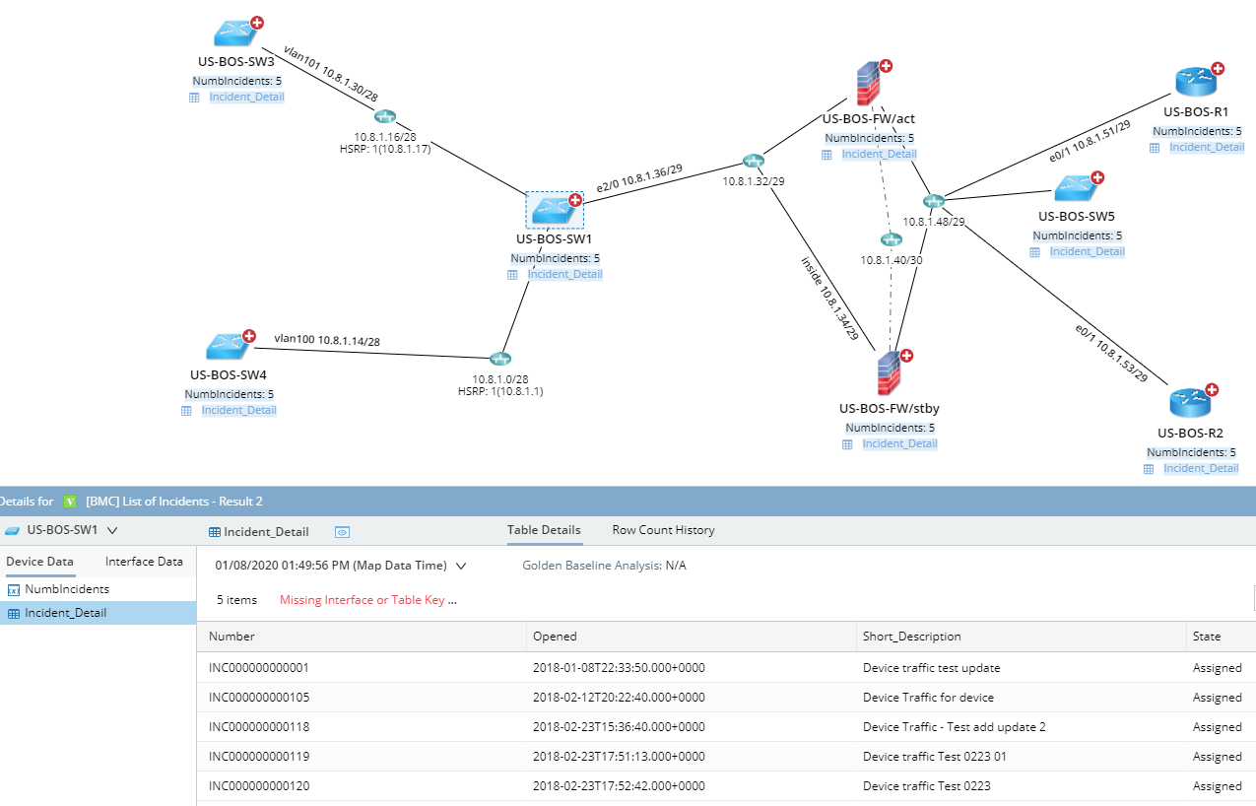

# Pre-requisites

## Application Version

Please confirm if your application is compatible with the integration.

|  |  |
| --- | --- |
| Application | Version |
| NetBrain Integrated Edition | **IEv8.0 (or newer)** |
| BMC Remedy | **Remedy ITSM 9.1.04 (or newer)** |

## Network Connectivity

It is required that there’s **HTTP/HTTPS** connectivity between the **NetBrain Front Server** and the **BMC Remedy server.**

## User Account and Privileges

|  |  |  |
| --- | --- | --- |
| Application | User Account | Required Role Assignment(s) |
| NetBrain Integrated Edition | Required | **System Admin** |
| BMC Remedy | Required | **Guest (or higher)** |

# Deployment Instructions

## Deploy the NetBrain BMC API Adaptor

1. Download the NetBrain BMC API Adapter, *BMC API Adaptor.py*, from the NetBrain github and stage locally on the machine typically used to connect to the NetBrain User Interface.
2. Using a web browser, login to the NetBrain System Management UI using the *System Admin* credentials

*http://<NetBrain Web Server IP>/admin*

1. In the NetBrain System Management UI, Navigate to *Operations > API Adaptors*.
2. In the *API Adaptors* screen, click “Add”.
3. Complete the *Add Adaptor* dialog screen as follows:

|  |  |
| --- | --- |
| **Field / Setting** | **Value** |
| **Adapter Name** | *BMC API Adaptor* |
| **Description** | *NetBrain BMC API Adaptor* |
| **Script** | *<BMC API Adaptor.py>* |

1. Review the adaptor configuration, then click “Save”.
2. Log out of the Netbrain Integrated Edition System Management UI.

## Create BMC API Server Connection

**Note:** If the environment has been deployed with multiple Front Servers, repeat this section for each of the Front Servers.

1. Using a web browser, login to the NetBrain Desktop UI using the *System Admin* credentials

http://<NetBrain Web Server IP>

1. Navigate to the NetBrain *API Server Manager*

*Domain Management > Operations > API Server Manager*

1. In the API Server Manager screen, click “Add”.
2. Complete the Add API Server dialog screen as follows:

|  |  |
| --- | --- |
| **Field / Setting** | **Value** |
| **Server Name** | *BMC API Adaptor* |
| **Description** | *NetBrain BMC API Adaptor* |
| **API Source Type** | *<BMC API Adaptor.py>* |
| **Endpoint** | *BMC instance endpoint (ex “http://192.168.31.99”)* |
| **Username** | *BMC guest account’s username* |
| **Password** | *BMC password* |
| **Front Server/Front Server Group** | Select FS/FSG which would have reachability to BMC server |

1. Click “Test” to initiate a connectivity test between the NetBrain front server and the BMC instance configured. Pictured below is the result of a successful connectivity test followed by two typical failure scenarios: Incorrect credentials and connectivity between NetBrain and BMC.

|  |  |
| --- | --- |
| **Successful Connection** |  |
| **Error Scenario:**  The entered credentials are incorrect.  **Possible Resolution:**  Confirm credentials specified in the BMC API Adaptor configuration and retry. |  |
| **Error Scenario:**  BMC endpoint is unreachable.  **Possible Resolution:**  Confirm that the NetBrain Front Server(s) can reach the BMC platform using 3rd party tools (Ping, Traceroute, Wireshark) |  |

1. Once successful connection with the local BMC instance has been confirmed, click “OK” to finalize BMC server connection.
2. Repeat Steps 2-6 for each additional deployed Front Server.

## Import BMC Data View Template

1. Download the NetBrain BMC Dataview Template, *[BMC] List of incidents.xdvt*, from the NetBrain github and stage locally on the machine used to connect to the NetBrain User Interface.
2. Using a web browser, login to the NetBrain Desktop UI with the *System Admin* credentials

*http://<NetBrain Web Server IP>*

1. Navigate to the NetBrain *Data View Template Manager*

*Start Menu (The Four Dashed Lines) > Dynamic Map > Data View Template Manager*

1. Right-Click “Shared Templates in Tenant”, then click “New Folder”.
2. Name the folder *BMC Single Pane of Glass*
3. Right-Click the “BMC Single Pane of Glass” folder, then click “Import Template”
4. In the *Import Data View Template* dialog, click “Add Data View Template …”
5. Select the *[BMC] List of Incidents.xdvt* file, then click “Open”.
6. Confirm that the *Import Data View Template* dialog screen reflects the following information:

**Name:** *[BMC] List of Incidents.xdvt*

**Size:** *12.32k*

**Status:** *Ready*

**Related Resources:** *1 Parser*

1. Click “Import” to initiate the import of the data view template to the NetBrain system.

**Note:** On successful completion, the status will transition from *Ready* to *Successful.* If any other status is reported, retry the operation, then contact NetBrain support.

1. Navigate to NetBrain *Parser Library*

*Start Menu (The Four Dashed Lines) > Automation > Parser Library*

1. In the Parser Library, search for “BMC“. Parser should be returned in the search results:

*[BMC] Incident List*

1. Double-click *[BMC] Incident List* to open the custom parser in the *Parser Editor*.
2. In the *Parser Editor*, update the *Parser Type* associated with the *[BMC] Incident List* to the following:

**Parser Type:** *API, BMC API Plugin*

1. Click the Save icon in the upper-right corner of the screen, then close the browser tab.

## Creating BMC Enabled Device Groups

**Note:** If the environment has been deployed with multiple Front Servers, repeat this section for each of the Front Servers.

1. Navigate to the NetBrain *Device Group Manager.*

*Start Menu (The Four Dashed Lines) > Device Group*

1. In the *Device Group Manager*, right-click the “Public” folder, then click “New Device Group”.
2. In the *Device Group Properties* dialog, Name the device group as follows:

*[BMC] DG <Front Server Hostname>*

1. Under *Devices and Interfaces*, click “+Dynamic Search”, then “Dynamic Search Device”.
2. In the *Dynamic Search Device* dialog,

**Search Scope:** *All Devices (default)*

**Device Criteria:** *Front Server | Matches | <Front Server>*

where *<Front Server>* is the front server specified in step 3.

1. Click “Search” to populate the device list to front server mapping.
2. Click “OK” button to create a *Dynamic Search* association.
3. In the *Device Group Properties* dialog, click “OK” to complete Device Group creation.
4. In the *Device Group Manager*, right-click the *[BMC] <Front Server Hostname>* object, then click “Open Group Map”.
5. In the resulting NetBrain device group map, right-click any device, then click “Shared Device Settings”.
6. In the *Shared Device Settings…* dialog, click the select the API tab then populate the dropdown fields as follows:

*BMC API Adaptor | BMC API Server <Front Server> | <Select Front Server>*

1. Check “Apply above Settings to device group”, then select *[BMC] DG <Front Server Hostname>*
2. In the API tab content table, check *BMC API Adaptor*
3. Click “Submit”.
4. Repeat steps 1-14 for each additional deployed Front Server.

# Visualizing the BMC Data with NetBrain Data View Template

## On-Demand Data Overlay

1. From the NetBrain Desktop Management UI, open the desired map to overlay BMC data.
2. In *Dynamic Data View* tab, search for “[BMC] List of Incidents”.
3. In the *Preview – Data View Template* dialog, click “Apply”
4. On the NetBrain map, confirm that the *Cache/Live* data source switch is set to *Live.*
5. Confirm that the objects (devices and interfaces) are properly instrumented with the expected BMC data.

**Note:** Overlay of the BMC data may take seconds-to-minutes to complete refresh depending on the number of devices on the map.

## Schedule Data Import from BMC

1. In the *NetBrain Domain Management* page, navigate to *Schedule Task*.
2. Click on “Schedule Data View Template/Parser”, then click on “Add Task”
3. In the *Add Task* dialog, specify the frequency for which to import device and interface data from BMC.
4. Click on “Device Scope” tab, then click “Device Group” radio button. Add each device group created as part of the integration to limit device scope of the available devices.
5. Click on “Select Data View Template/Parser” tab, click on “Add” and search for *[BMC] List of Incidents*
6. Click “Submit” to create the scheduled task for BMC data import to NetBrain.

**Note:** The BMC data will not be available on the map until after the first time that the scheduled task has completed execution.

# Troubleshooting

If there are any problems encountered during deployment or integration of NetBrain with BMC, contact NetBrain Support at support@netbraintech.com.